Project Sentinel-Grid: AI-Driven ICS Security
Author: Sandra Weiß | Focus: KRITIS Protection & Industrial AI Target: Siemens Energy Internship / Master’s AI Specialization

1. Problem Statement
The energy industry’s Status Quo relies on "Threshold Detection" (e.g., Alarm if Voltage > 280V). This leaves Critical Infrastructure (KRITIS) vulnerable to sub-threshold attacks—malicious activities that remain within "safe" limits but aim to damage physical assets or cause grid instability.

2. The Solution: Proactive AI Defense
This project shifts from reactive rules to Proactive Behavioral Analysis. Using an Isolation Forest (Unsupervised Machine Learning), the system learns the "Normal Operational Footprint" of a power grid and identifies anomalies that are "few and different."

3. Technical Implementation
- Dataset: Real-world power grid telemetry (Voltage, Current, Frequency).
- Feature Engineering: Implemented a 10-point Rolling Mean. This gives the AI "Short-term Memory," allowing it to compare the current state against the recent trend.
- Model: IsolationForest (Scikit-Learn).
- Hyper-parameters: Set contamination=0.005 (0.5%) to minimize Alarm Fatigue, ensuring only the most critical threats reach the operator.

4. Adversarial Stress Testing (Red Teaming)
To validate the model, I simulated two sophisticated cyber-physical attacks:

Attack A: The Replay Attack
- Method: A 50-point segment of "perfect" normal data was intercepted and "replayed" over a period of actual grid volatility.
- Detection: The AI flagged the "seams" of the attack—the precise moments where the live data stream transitioned into the recorded loop.

Attack B: Man-in-the-Middle (MITM) Bias
- Method: Injected a constant +15V bias into the sensor stream. This simulates a hacker subtly tricking a controller into overcompensating.
- Detection: The AI identified a sustained statistical "drift." Because the raw data pulled away from the rolling mean too quickly, the model flagged the entire period as an anomaly.
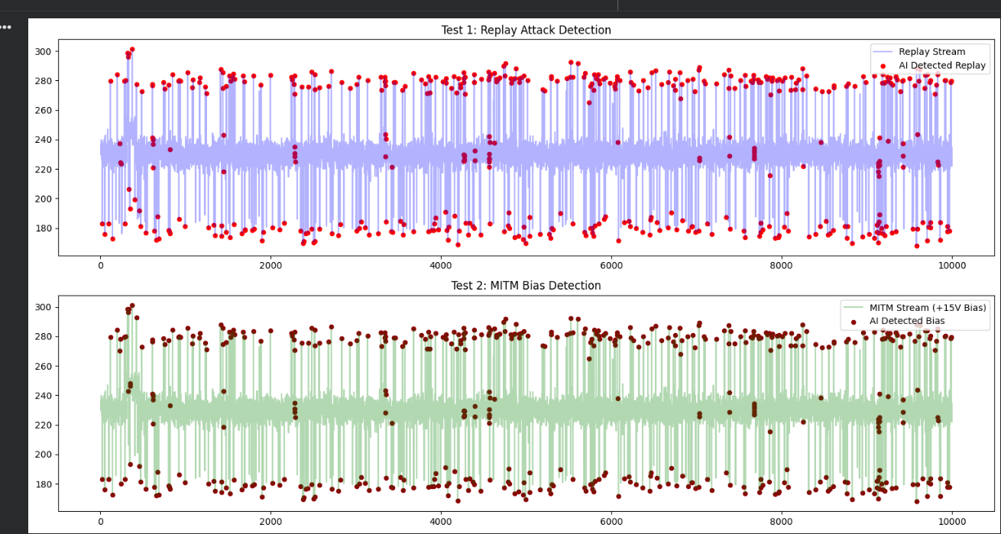

5. Key Insights & Portfolio Reflections
- Model Robustness: Both attacks triggered similar anomaly signatures. This proves the model has Generalized the concept of "Normalcy." It does not need a specific signature to catch a new (Zero-Day) attack.
- Trend vs. Threshold: Traditional systems missed both attacks because they stayed within the 180V–280V "Safe Zone." Sentinel-Grid caught them by analyzing the Temporal Correlation between data points.
- Human-Centric Design: By tuning the contamination rate, the system acts as an AI-Copilot, reducing noise for the control room operators in Karlsruhe or Orlando.

6. Future Roadmap
- Multi-Variate Analysis: Correlating Voltage with Frequency and Current simultaneously.
- Explainable AI (XAI): Using SHAP values to explain why the AI flagged a specific point.
- Edge Implementation: Deploying the model on Siemens Scalance or Simatic hardware for real-time inference.

